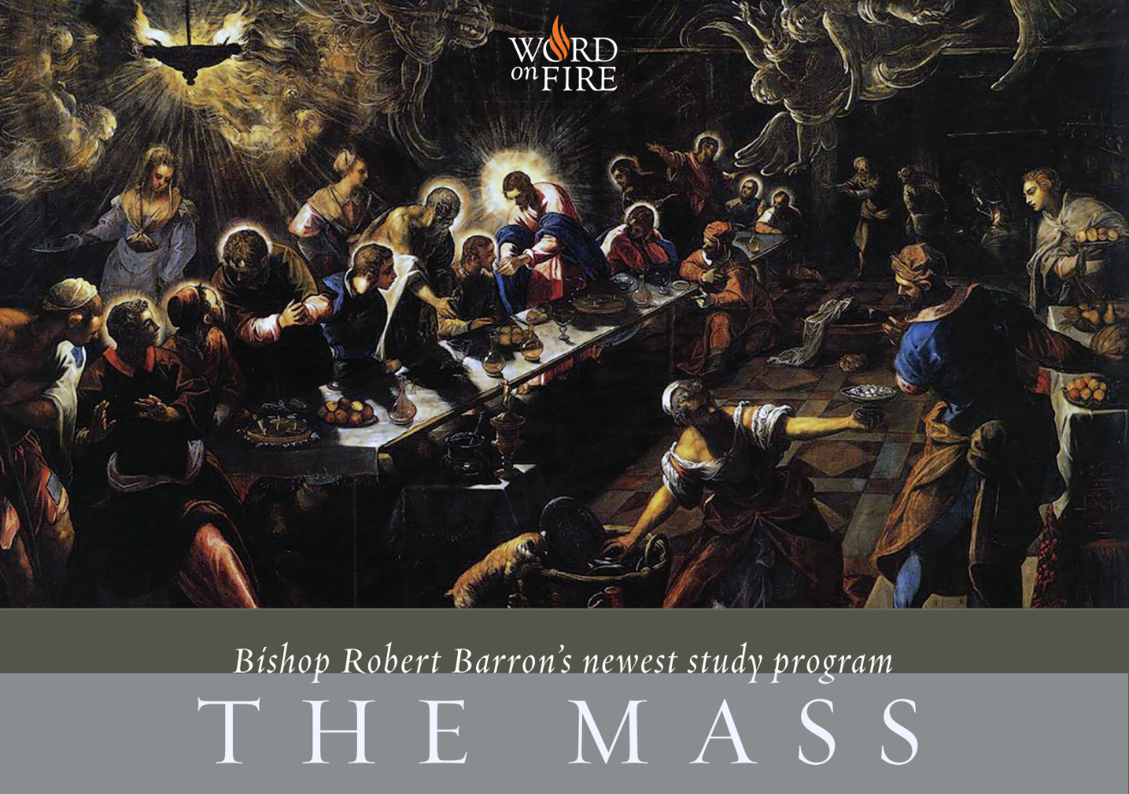**Bishop Robert Barron’s *The Mass* Study Program Registration**

To register for the upcoming *The Mass Series* program, please complete this form and return it to the LT Office by Wednesday prior to the start of the first session.   
An optional donation to keep the program going of $30 can be submitted to the LT Office and a receipt will be given to you.

Or for your convenience you can send electronically through the Square Cash App [cash.me/$StMarthaYAM](http://cash.me/$StMarthaYAM) or Cashtag $StMarthaYAM. Please indicate this is for *The Mass Series* and leave an email address for your receipt.

Name __________________________________________________________________________________

Address________________________________________________________________________________

City ______________________ Preferred phone number: ___________________________

Email address: ________________________________________________________________________